

SIMATS SCHOOL OF ENGINEERING
SAVEETHA INSTITUTE OF MEDICAL AND TECHNICAL SCIENCES
CHENNAI-602105

CREATING A WEBSITE ON BLOOD BLANK MANAGEMENT SYSTEM

A CAPSTONE PROJECT REPORT

Submitted in the partial fulfillment for the award of the degree of
BACHELOR OF ENGINEERING
IN
COMPUTER SCIENCE AND ENINEERING

Submitted by
P. Aasreetha (192211746)
J. Poojitha (192211829)

Under the Supervision of
Dr. S.K. Saravanan

JULY 2024

DECLARATION

We P. Aasreetha and J .Poojitha, students of Bachelor of Engineering in CSE, Department of Computer Science and Engineering, Saveetha Institute of Medical and Technical Sciences, Saveetha University, Chennai, hereby declare that the work presented in this Capstone Project Work entitled CREATING A WEBSITE ON BLOOD BANK MANAGEMMENT SYSTEM is the outcome of our own bonafide work and is correct to the best of our knowledge and this work has been undertaken taking care of Engineering Ethics.

(P. Aasreetha 192211746)
(J. Poojitha 192211829)

Date:
Place:

CERTIFICATE

This is to certify that the project entitled “CREATING A WEBSITE ON BLOOD BANK MANAGEMENT SYSTEM” submitted by P.Aasreetha and J.Poojitha has been carried out under my supervision. The project has been submitted as per the requirements in the current semester of B. Tech Information Technology.

Dr. S.K. Saravanan
Teacher-in-charge

Table of contents

S.NO | TOPICS | page no
1 | Abstract | 5
2 | Introduction | 5
3 | Project Description | 5
4 | Problem Description | 6
5 | Tool Description | 6
6 | Operations | 7
7 | Module Description  7.1 User Interaction Module | 8
8 | Implementation | 9
9 | Result | 20
10 | Conclusion | 20
 | Future Enhancements | 21
 | Screenshots | 21
 | References | 24

1. ABSTRACT:
The proposed project aims to develop a comprehensive blood bank management website to streamline blood donation, storage, and distribution processes. Leveraging modern web technologies, the system offers a user-friendly interface for donors, blood bank staff, and healthcare providers. Key features include donor registration, real-time inventory tracking, automated notifications, and blood compatibility testing. The robust database ensures data accuracy and accessibility, enhancing efficiency through automated reminders and alerts. The system also prioritizes blood quality and safety with stringent checks and real-time tracking. Comprehensive reporting and analytics provide insights into donor demographics and blood usage patterns, aiding in operational optimization. Overall, the website aims to improve the efficiency of blood banks, enhance donor engagement, and save lives.

2.INTRODUCTION:
The Blood Bank Management System is a modern web application designed to streamline blood bank operations, providing a seamless experience for donors, recipients, and staff. This system enhances efficiency, accuracy, and accessibility by offering features like donor registration, inventory tracking, and automated notifications. It also includes a secure database, real-time inventory management, and resources for donor education. By leveraging advanced technology, the system optimizes operations, fosters a community of committed donors, and ensures timely availability of critical blood resources. This initiative represents a significant advancement in healthcare, aiming to save lives and improve the overall experience of blood donation and transfusion services.

3.PROJECT DESCRIPTION:
Creating a website for a Blood Bank Management System requires several key features and components to ensure it operates efficiently and effectively.

Proposed Method
- Frontend Development: Utilizing Visual Studio for designing responsive and intuitive user interfaces.

- Backend Development: Using XAMPP stack (Apache, MySQL, PHP) to handle server-side scripting, database management via phpMyAdmin, and ensuring secure data storage and retrieval.

4.PROBLEM DESCRIPTION:

Existing system
The existing blood bank management systems often rely on manual processes or outdated digital solutions, leading to inefficiencies and inaccuracies. Many blood banks still use paper-based records or rudimentary software for tracking donations, inventory, and donor information. These methods can result in delays in data retrieval, increased risk of errors, and challenges in maintaining accurate, up-to-date records. Additionally, communication with donors and recipients is typically manual, which can lead to slow response times, especially in emergencies. Inventory management is another critical area where traditional systems fall short, often lacking real-time tracking and automated alerts for low supplies.
Overall, the current systems are not sufficiently equipped to handle the dynamic and urgent needs of blood bank operations, which can compromise the timely availability of blood and reduce the quality of service to donors and recipients.

Proposed System
The proposed Blood Bank Management System (BBMS) aims to overcome the limitations of existing systems by leveraging modern web technologies to create a comprehensive, efficient, and user-friendly platform. This system integrates advanced features such as a digital donor registration module, real-time inventory tracking, and automated notification systems for both donors and recipients. The BBMS ensures secure data management, protecting sensitive information while providing easy access for authorized personnel. It offers a streamlined process for scheduling donations, monitoring donation history, and managing blood requests. The real-time tracking of blood inventory, categorized by blood type and expiration date, allows for precise and efficient resource allocation, minimizing wastage. Automated alerts for low inventory levels and eligibility reminders for donors enhance operational efficiency and responsiveness.
Additionally, the system includes educational resources and awareness campaigns to encourage more people to donate blood. By adopting this advanced, data-driven approach, the proposed BBMS not only optimizes blood bank operations but also enhances the overall experience for all stakeholders, ultimately aiming to save more lives by ensuring timely and adequate blood supply.

5.TOOL DESCRIPTION:

Hardware and Software Tools
To develop and deploy the online tollgate web application, the following hardware and software tools were utilized:
Hardware Specifications
- Laptop Model: HP PAVILION x360
- Graphics Card: NVIDIA GeForce RTX 3050, 8GB
- Storage: 1TB SSD
- RAM: 16GB
- Processor: 12th Gen Intel(R) Core(TM) i7-1255U 1.70 GHz
Software Tools
- Visual Studio Code: An integrated development environment (IDE) used for writing and debugging code. Its extensions and integrated terminal enhanced the coding experience.
- XAMPP: A free and open-source cross-platform web server solution stack package developed by Apache Friends. It provided the necessary Apache, MySQL, PHP, and Perl support for local development and testing.
- phpMyAdmin: A free software tool written in PHP, intended to handle the administration of MySQL over the web. phpMyAdmin was used for database management, allowing for easy handling of the MySQL database used in the application.
- Google Chrome: The primary web browser used for testing and debugging the web application. Developer tools in Chrome facilitated real-time inspection and modification of the front-end code.
The combination of powerful hardware and a robust set of development tools provided a conducive environment for the efficient development, testing, and deployment of the recipe management web application.

6. OPERATIONS
The Blood Bank Management System (BBMS) offers a range of operations to streamline the management of blood donations and ensure a smooth experience for all users. Below are the detailed operations based on the functionalities of the system:

6.1 User Operations
Interacting with Donor and Blood Records
- View Donor Records: Users can browse and view detailed information about donors, including donor name, blood type, contact information, medical history, and donation history. This feature helps track and manage donor contributions efficiently.
- View Blood Inventory: Users can access detailed information about the blood inventory, including blood type, quantity available, and expiration dates. This ensures that the blood bank can manage stock levels and prevent shortages.
- Search Donor and Blood Records: Users can search for specific donor records or blood types using criteria such as donor name, blood type, or donation date. This functionality aids in quickly locating relevant records for processing or review.
- Filter by Blood Type or Date: Users can filter blood inventory records to display entries for a specific blood type or within a certain date range. This is useful for monitoring the availability of specific blood types and managing stock rotation based on expiration dates.
Taking Actions on Donor and Blood Records
- Submit Donor Information: Donors can submit their personal and medical information through an online form, providing details such as name, blood type, contact information, and medical history. This data is securely stored in the system's database for future reference and eligibility verification.
- Record Blood Donations: Administrators can record details of blood donations, including the donor's name, blood type, quantity donated, and donation date. These records are crucial for tracking donations and managing inventory levels.
- Update Donor and Blood Information: Users with the appropriate permissions can update donor information and blood inventory records as needed. This includes modifying contact details, medical history, or adjusting inventory quantities based on new donations or usage.
- Search Donor and Blood Records: The search functionality allows users to locate specific donor records or blood products based on criteria such as blood type, donor name, or donation date. This feature ensures efficient management and retrieval of records.
- Filter by Blood Type or Date: Users can filter records by blood type or specific dates to streamline the viewing and management process. This feature helps in focusing on particular data subsets, such as finding donors of a specific blood type or tracking recent donations.
By organizing these operations, the Blood Bank Management System provides an efficient and user-friendly platform for managing blood donations and inventory. The system's capabilities ensure accurate record-keeping, timely responses to blood shortages, and enhanced coordination between donors and the blood bank staff.

7. MODULE DESCRIPTION
To develop the Blood Bank Management System (BBMS), the project is divided into distinct modules, each handling specific functionalities. This modular approach ensures ease of maintenance, scalability, and a seamless user experience.
Modules and Functionalities
7.1 Interaction Module (User)
Function: Home Page
- Description: Provides users with an introductory overview of the Blood Bank Management System.
- Functionalities:
  - Display a welcome message along with a brief description of the BBMS.
  - Include a call-to-action button for users to register as donors or request blood.
Function: About Us Page
- Description: Offers detailed information about the BBMS, its purpose, and mission.
- Functionalities:
  - Present information on the goals and benefits of the BBMS, such as enhancing the efficiency of blood donation and distribution.
  - Include background details about the blood bank's history, mission, and the importance of blood donation.
Function: Contact Form
- Description: Allows users to send inquiries, provide feedback, or request additional information through a contact form.
- Functionalities:
  - Provide input fields for users to enter their name, email address, subject, and message.
  - Implement form validation to ensure that all required fields are correctly filled out.
  - Submit the form data to the server for processing and ensure a response mechanism is in place.

Function: Search Blood Records
- Description: Enables users to search for specific blood records based on criteria such as blood type, availability status, or date of donation.
- Functionalities:
  - Allow users to filter and display blood records based on their search input.
  - Dynamically update the search results as the user refines their criteria, such as selecting specific blood types or dates.
  - Display the results with relevant details, including blood type, quantity available, and expiration dates, to assist in quick decision-making.
By structuring the system into these modules, the Blood Bank Management System provides a comprehensive and user-friendly platform for managing blood donation and inventory. Each module focuses on specific interactions, ensuring a clear and intuitive experience for users, whether they are donors, recipients, or administrative staff.
.

8.Implementation:
Home page code:
<!DOCTYPE html>
<html lang="en">
<head>
<meta charset="UTF-8">
<meta name="viewport" content="width=device-width, initial-scale=1.0">
<title>Blood Bank Management System</title>
<style>
body {
font-family: Arial, sans-serif;
margin: 0;
padding: 0;
background-color: #f4f4f4;
}
header {
background-color: #d9534f;
color: white;
padding: 1rem 0;
text-align: center;
}
nav {
display: flex;
justify-content: center;
background-color: #f4f4f4;
padding: 0.5rem;
}
nav a {
margin: 0 1rem;
text-decoration: none;
color: #333;
}
.container {
padding: 2rem;
text-align: center;
}
.button {
background-color: #d9534f;
color: white;
padding: 0.5rem 1rem;
text-decoration: none;
border-radius: 5px;
margin: 0.5rem;
}
.button:hover {
background-color: #c9302c;
}
footer {
background-color: #333;
color: white;
text-align: center;
padding: 1rem 0;
position: fixed;
width: 100%;
bottom: 0;
}
.form-container {
background-color: rgba(0, 0, 0, 0.5);
padding: 2rem;
margin: 2rem auto;
width: 80%;
max-width: 600px;
border-radius: 10px;
color: white;
}
input, select {
padding: 0.5rem;
margin: 0.5rem 0;
border-radius: 5px;
border: 1px solid #ddd;
width: 100%;
}
</style>
</head>
<body>
<header>
<h1>Blood Bank Management System</h1>
</header>
<nav>
<a href="login.html">login</a>
<a href="index.html">Home</a>
<a href="aboutus.html">About Us</a>
<a href="contact.html">Contact</a>
</nav>
<div class="container">
<h2>Welcome to the Saveetha Blood Bank Management System</h2>
<p>Your contribution can save lives. Join us in making a difference.</p>
</div>
<footer>
<p>&copy; 2024 Blood Bank Management System. All rights reserved.</p>
</footer> </body> </html> </head>

Database retrieval:

<?php
// Database configuration
$server = "localhost:3306";
$username = "root";
$password = ""; // Leave this empty if the root user has no password
$dbname = "bbms";

// Create a connection
$conn = new mysqli($server, $username, $password, $dbname);

// Check the connection
if ($conn->connect_error) {
die("Connection failed: " . $conn->connect_error);
}

// Function to sanitize input data
function sanitizeInput($data) {
return htmlspecialchars(stripslashes(trim($data)));
}

// Validate and sanitize form inputs
$username = sanitizeInput($_POST['username']);
$password = sanitizeInput($_POST['password']);

// Hash the password
$hashedPassword = password_hash($password, PASSWORD_DEFAULT);

// Prepare and execute the SQL statement
$stmt = $conn->prepare("INSERT INTO login (Username, Password) VALUES (?, ?)");
$stmt->bind_param("ss", $username, $hashedPassword);

if ($stmt->execute()) {
echo "Login successful!";
$stmt->close();
$conn->close();
header("Location: index.html"); // Redirect to index.html after successful registration
exit();
} else {
echo "Error: " . $stmt->error;
}

// Close the statement and connection
$stmt->close();
$conn->close();
?>

Login page code:
<!DOCTYPE html>
<html lang="en">
<head>
<meta charset="UTF-8">
<meta name="viewport" content="width=device-width, initial-scale=1.0">
<title>Blood Bank Management System - Login</title>
<style>
body {
font-family: Arial, sans-serif;
background-color: #ff4c4c; /* Changed background color to red */
display: flex;
justify-content: center;
align-items: center;
height: 100vh;
margin: 0;
}

.login-container {
background-color: #fff;
padding: 20px;
border-radius: 8px;
box-shadow: 0 0 10px rgba(0, 0, 0, 0.1);
width: 300px;
text-align: center;
}

h2 {
margin-bottom: 20px;
color: #333;
}

.form-group {
margin-bottom: 15px;
text-align: left;
}

label {
display: block;
margin-bottom: 5px;
color: #555;
}

input[type="text"],
input[type="password"] {
width: 100%;
padding: 10px;
border: 1px solid #ddd;
border-radius: 4px;
box-sizing: border-box;
}

button.btn {
width: 100%;
padding: 10px;
background-color: #5cb85c;
border: none;
border-radius: 4px;
color: white;
font-size: 16px;
cursor: pointer;
}

button.btn:hover {
background-color: #4cae4c;
}
</style>
</head>
<body>
<div class="login-container">
<h2>Blood Bank Management System</h2>
<form action="index.html" method="POST">
<div class="form-group">
<label for="username">Username:</label>
<input type="text" id="username" name="username" required>
</div>
<div class="form-group">
<label for="password">Password:</label>
<input type="password" id="password" name="password" required>
</div>
<button type="submit" class="btn" onclick="windows.location.href='index.html'">Login</button>
</form>
</div>
</body>
</html>

Database connectivity:
<?php
error_reporting(E_ALL);
ini_set('display_errors', 1);

// Database configuration
$servername = "localhost:3306"; // Your MySQL server name
$username = "root"; // Your MySQL username
$password = ""; // Your MySQL password
$dbname = "bbms"; // Your database name

// Create connection
$conn = new mysqli($servername, $username, $password, $dbname);

// Check connection
if ($conn->connect_error) {
die("Connection failed: " . $conn->connect_error);
}

// Prepare and bind
$stmt = $conn->prepare("INSERT INTO donor (name, email, phone, address, blood_type, date, time) VALUES (?, ?, ?, ?, ?, ?, ?)");
if (!$stmt) {
die("Prepare failed: " . $conn->error);
}
$stmt->bind_param("sssssss", $name, $email, $phone, $address, $blood_type, $date, $time);

// Set parameters and execute
$name = $_POST['name'];
$email = $_POST['email'];
$phone = $_POST['phone'];
$address = $_POST['address'];
$blood_type = $_POST['blood_type'];
$date = date("Y-m-d"); // Current date
$time = date("H:i:s");

if ($stmt->execute()) {
// Close statement and connection
$stmt->close();
$conn->close();

// Redirect after successful registration
header("Location: index.html");
exit();
} else {
echo "Error: " . $stmt->error;
}

// Close statement and connection
$stmt->close();
$conn->close();
?>

9.RESULT:
The Blood Bank Management System (BBMS) offers a comprehensive solution for managing blood donations and inventory. It enhances efficiency, accuracy, and accessibility by providing a user-friendly interface for donors, recipients, and staff. The system includes modules for donor registration, real-time inventory tracking, and automated notifications, ensuring timely and adequate blood supply. Users can easily search and filter blood records, submit and update donor information, and access educational resources about blood donation. The BBMS also ensures secure data management and compliance with regulatory standards. By optimizing blood bank operations and fostering a community of committed donors, the BBMS aims to save lives and improve the overall experience of blood donation and transfusion services.

10. CONCLUSION:
In conclusion, the Blood Bank Management System represents a significant advancement in the field of healthcare, providing a comprehensive, efficient, and user-friendly platform for managing blood donation and distribution. By leveraging modern web technologies, the system streamlines various aspects of blood bank operations, including donor registration, inventory tracking, and blood compatibility testing. Its automated notification and reminder features ensure timely donations and efficient stock management, thereby reducing shortages and wastage. The secure handling of sensitive data and the inclusion of educational resources further enhance the user experience, fostering a more informed and engaged donor community. Ultimately, this system not only optimizes the operational efficiency of blood banks but also plays a crucial role in saving lives by ensuring that safe and compatible blood is readily available to those in need. Through these advancements, the Blood Bank Management System sets a new standard in the management of vital healthcare resources, contributing to the overall improvement of public health outcomes.

11.FUTURE ENHANCEMENTS:
Future enhancements for the Blood Bank Management System (BBMS) include integrating advanced analytics and AI to predict blood demand and optimize inventory, developing a mobile app for easier donor access, and improving system interoperability with electronic health records (EHRs). Additional improvements could involve incorporating blockchain technology for enhanced data security and transparency, and expanding educational resources to encourage more donations. These upgrades aim to enhance the system's efficiency, user engagement and overall effectiveness.

SCREEN SHOTS
en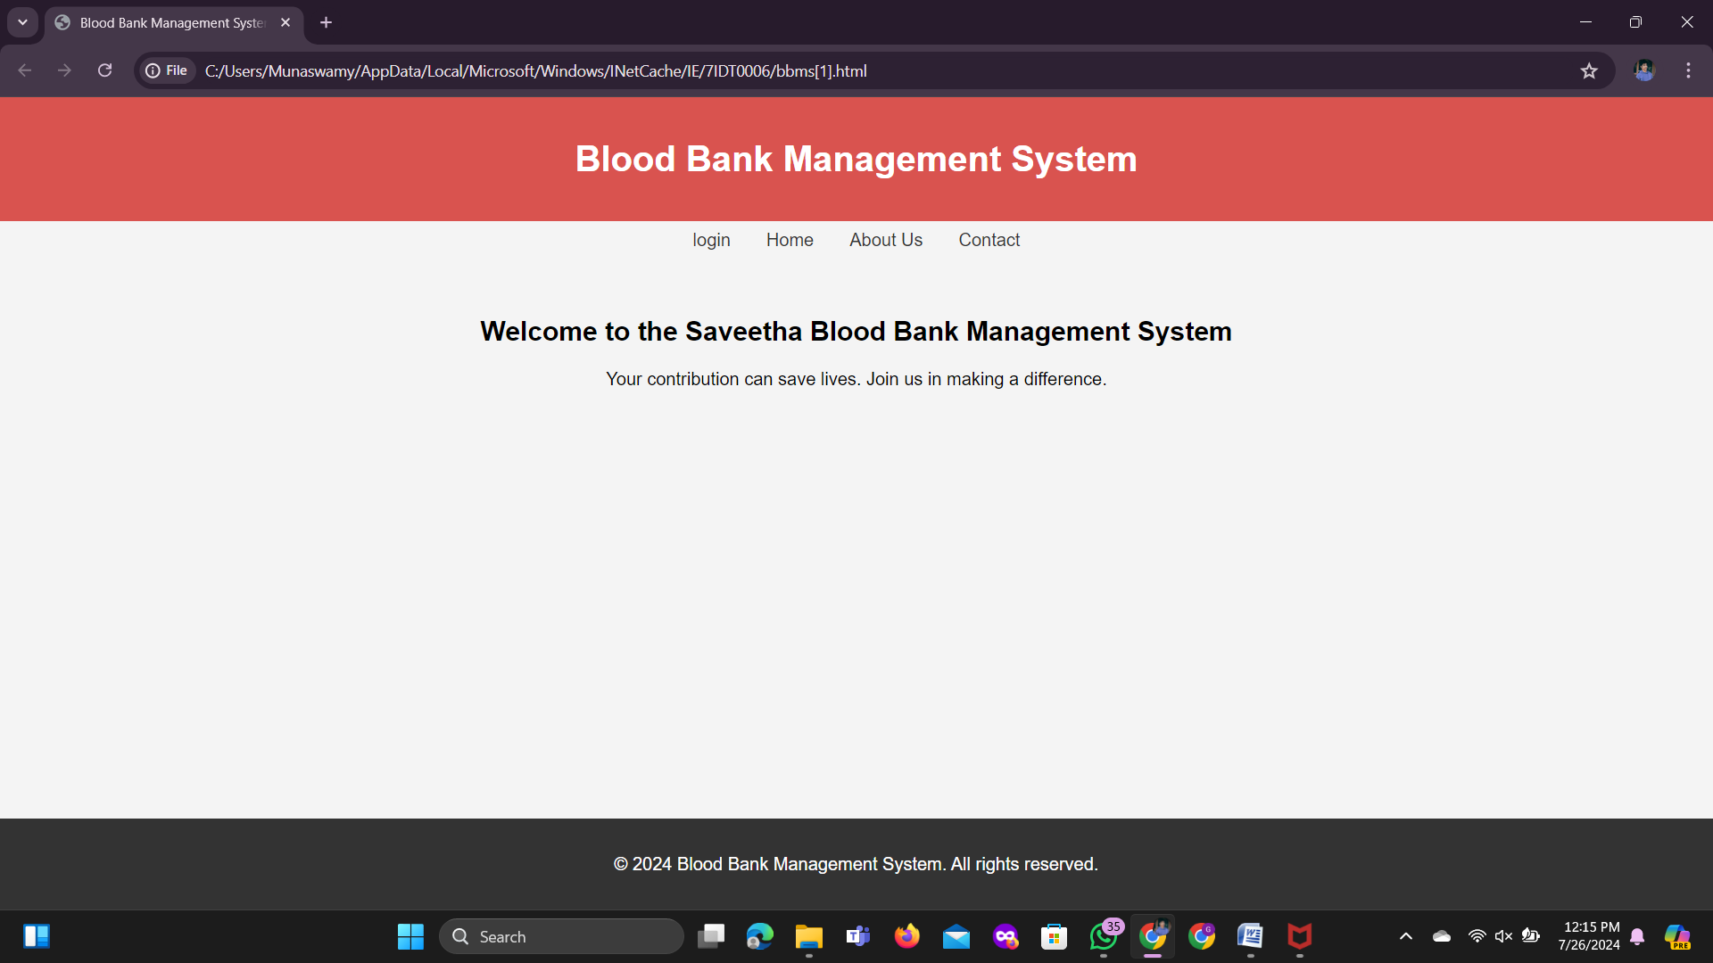
Fig 1: Welcome Page
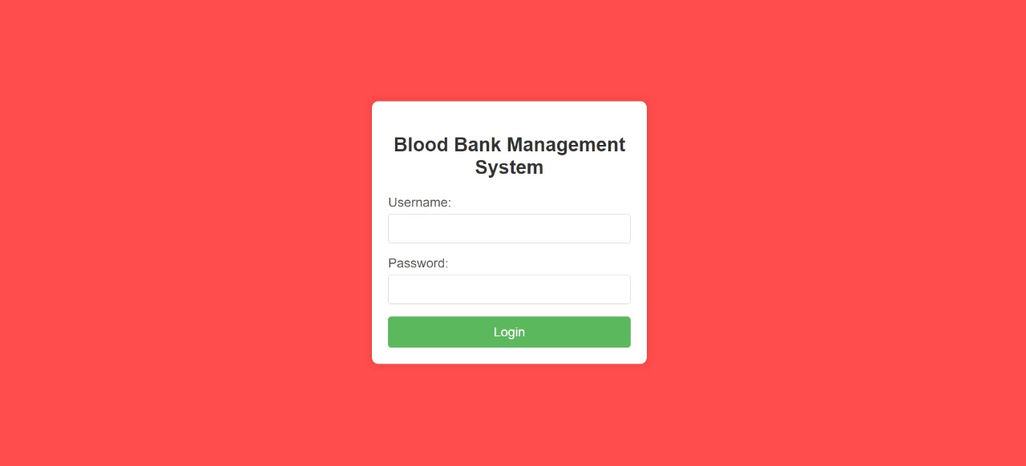
Fig 2: Login Page
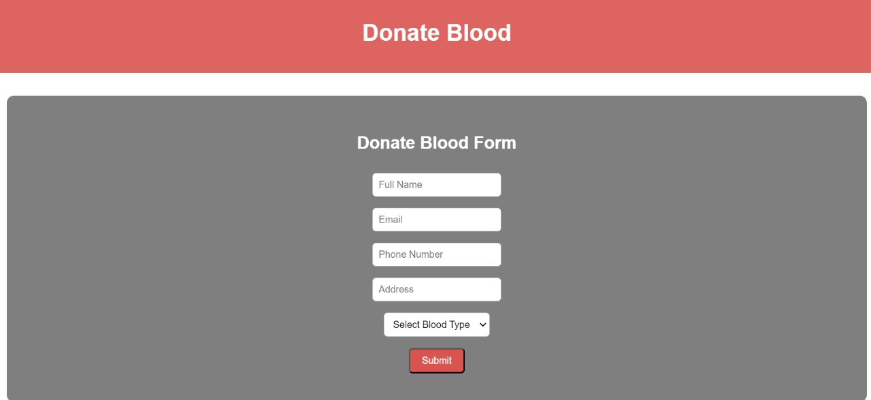
Fig 3: Donate Form

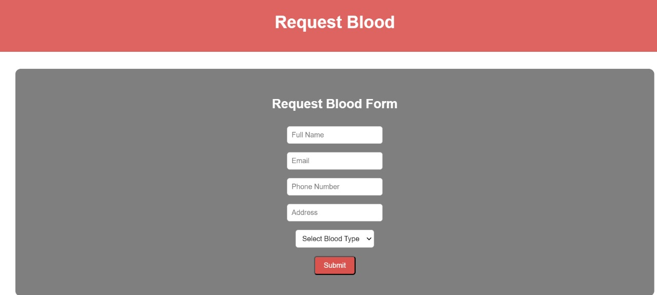
Fig 4: Request Form
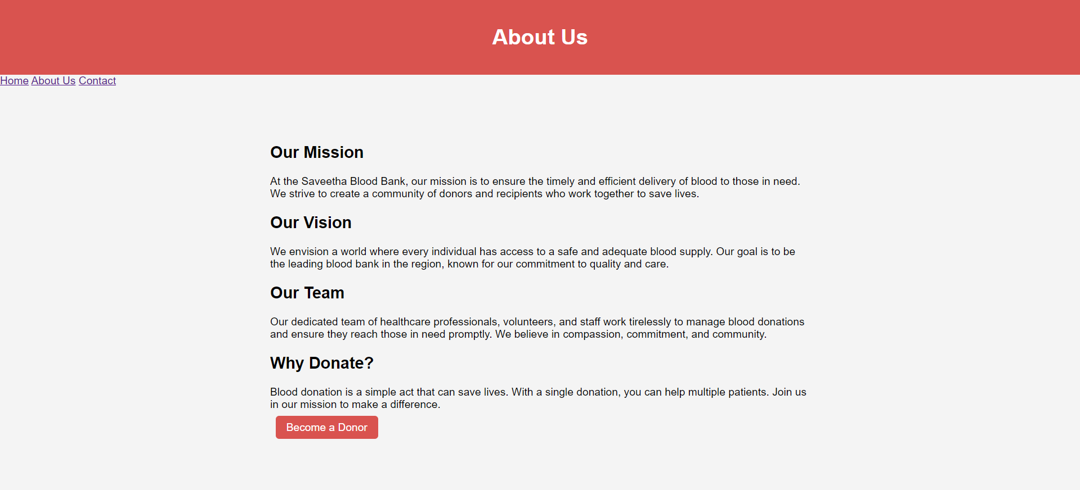
Fig 5: About Us Page

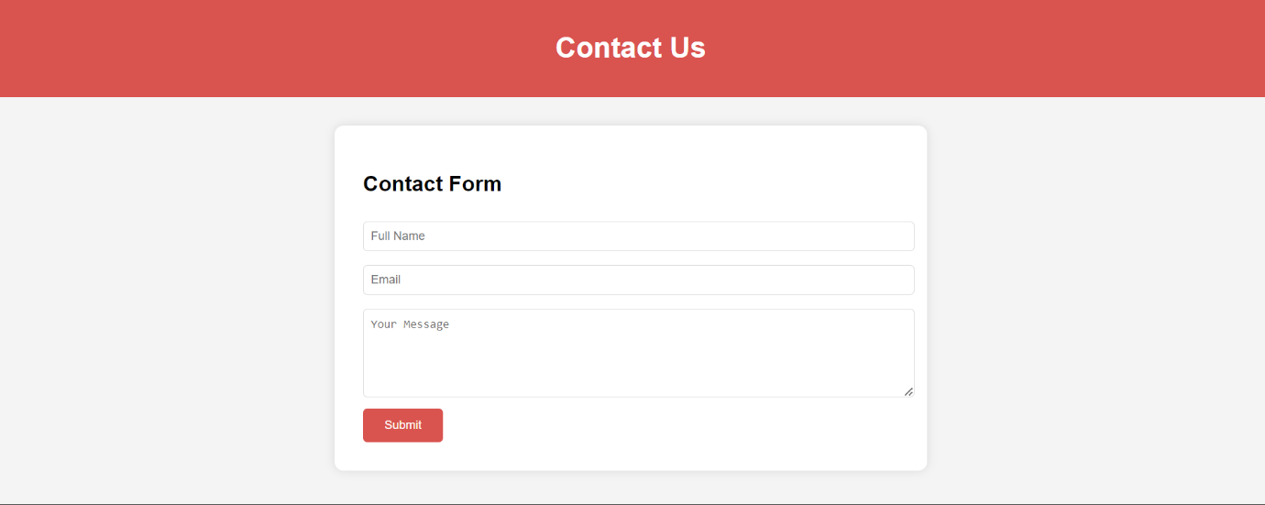
Fig 6: Contact Page

11.REFERENCES:
- http://www​.who.int/bloodsafety​/transfusion_services​/bts_learningmaterials​/en/index.html.
- http://www​.who.int/bloodsafety​/voluntary_donation​/blood_donor​_selection_counselling/en/ [PubMed]
- . http://www​.who.int/bloodsafety​/publications​/who_bct_02_03/en/index.html.
- http://www​.who.int/worldblooddonorday​/Melbourne​_Declaration_VNRBD_2009.pdf.
- http://www​.who.int/bloodsafety​/voluntary_donation​/blood_donor​_selection_counselling/en/ [PubMed]

